New personalised maps of ‘The Alps - Skiing by Train’ and free 2022 London Christmas Lights map
Winter-sports mapping specialists, 2theAlps, are pleased to offer new personalised versions of their popular ski resort maps. The maps can be centred on any part of the Alps in a range of ski holiday-themed shapes including ski boots, skiers and suitcases. See the full range at https://www.cosmographics.co.uk/product/personalised-skiing-in-the-alps-map-gift-uk-free-delivery/.
The base map is our London Underground style rail map of the Alps which includes over 200 resorts, most of which can be reached by train.
We have also updated our London Christmas Lights map to highlight the best of the 2022 displays. The map, available for free on 2theAlps website www.2thealps.com/london-christmas-lights-2022.htm includes the classic displays on Oxford Street and Regent Street as well as many lesser-known delights. As usual, the 2theAlps research team used bikes to assess the displays but they can now be reached via the Elizabeth Line with two stations in the heart of London’s Christmas-lights land.
2theAlps offers a range of original maps of the Alps, mainly with a specific focus on travelling by train. We have also teamed up with Redbubble to offer our maps across a range of formats including rucksacks, shower curtains, bath mats and duvet covers.
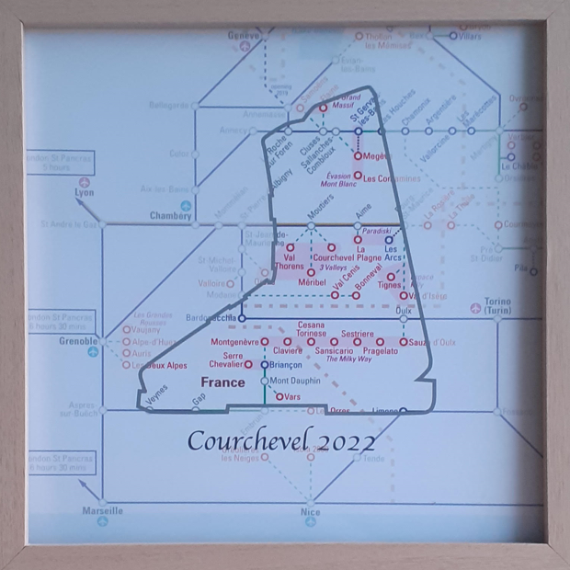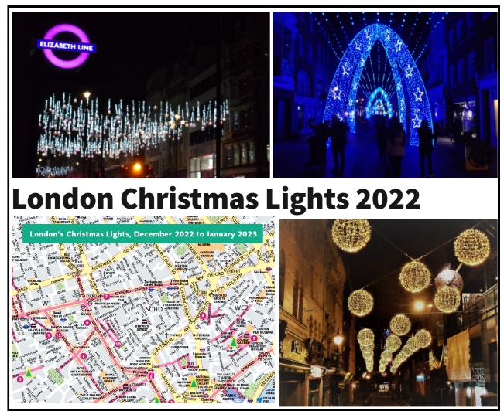

enquiries@2thealps.com www.2thealps.com @2thealps 01923 277963

